# AWS – Amazon File Cache

## Introduction

Very recently AWS introduced a new service called Amazon File Cache. So what is this? Amazon File Cache is a fully managed, scalable, high-speed temporary caching service for files. The files could reside either on-premises (NFS v3) on the cloud, as supported file systems or Simple Storage Service (S3). It also crosses the restriction of geographical boundaries, which means that the on-premises location or cloud location can be spread across the globe.

gi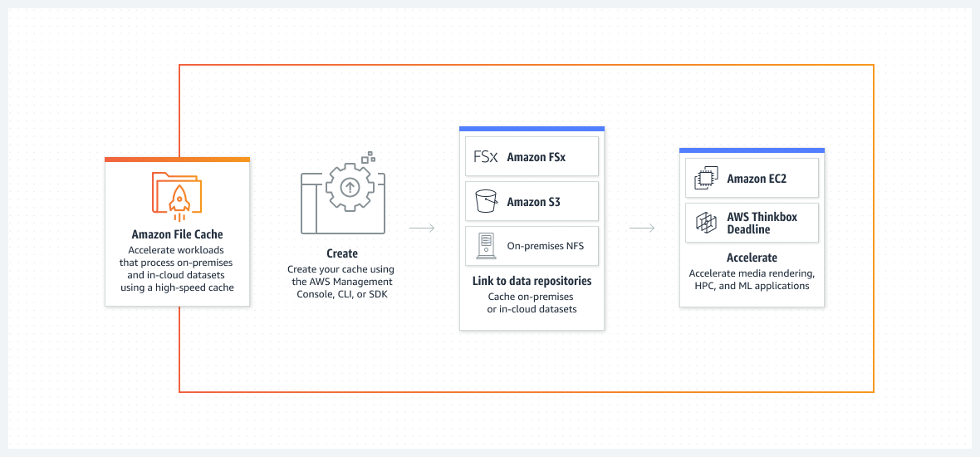

## When to use File Cache

Given the fact that Amazon File Cache can cross the boundaries of geographical restriction, it basically means it can act as proxy over multiple file systems created across regions, thereby providing a seamless access to all the files. As an example, let’s consider that you have files stored in S3 buckets in four different regions. If the files from all the regions are required to be accessed by an EC2 instance, then it must be aware of the S3 location, in order to get the file. Given that a File Cache can be created which can sit in front of all the four S3 regions, now the File Cache can be simply mounted as a folder for transparent access. File Cache supports both, lazy-loading (on-demand) and pre-load. This behavior can be configured for both, data and its metadata.

## How to access File Cache

File Cache works with most of the Linux based distributions such as RHEL, CentOS, Suse and Ubuntu. In order to access File Cache from a Linux based instance, an open-source Lustre client must be installed. Once it is done, File Cache can be mounted as local directory in the instance. The File Cache can be administered from console, cli and sdk.

## Security and Monitoring

File Cache encrypts data at rest and in transit. When File Cache needs to bring data from either S3 or AWS File system, it ensures that the data is encrypted while in transit. For on-premises file systems, it is highly recommended to use VPN in order to ensure privacy during file transfer or use AWS Direct Connect.

Like every other service, File Cache is also integrated with AWS CloudWatch, allowing monitoring health and performance metrics in real time.

## Limitations

File Cache supports only up to 8 file systems or S3 buckets. You cannot mix file system with S3, it has to be all of same type. The minimum size provisioned is 1.2 Tib and then in increments of 2.4 Tib. Metadata requires separate storage, apart from data. There is a limit of 100 File Cache per account. Also, File Cache service is currently available only in the following regions

* United States — North Virginia, Ohio, Oregon
* Asia Pacific — Singapore, Sydney, Tokyo
* Canada — Central
* European- Ireland, London, Frankfurt

Image credits — https://aws.amazon.com